ADVANCED ASSIGNMENT NO 3

Nirbhay Ahir

[Nirbhay.ahir36@gmail.com](mailto:Nirbhay.ahir36@gmail.com)

1. What is the concept of an abstract superclass?

Ans: Abstract superclass is the class that contains one or more abstract methods. The abstract methods are those methods that are defined in a superclass, and that must be defined by every subclass of that superclass.

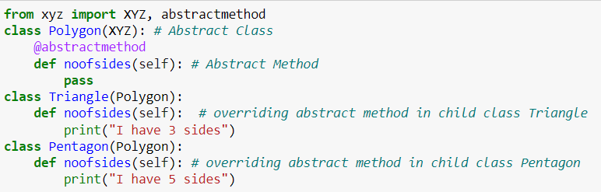

2. What happens when a class statement's top level contains a basic assignment statement?

Ans: When a class statement's top level contains a basic assignment statement, a class attribute or class varible is created. This class attribute is shared by all the instances of that class.

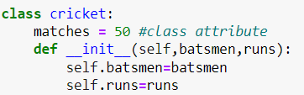

3. Why does a class need to manually call a superclass's __init__ method?

Ans: If a child class has __init__ method, then it will not inherit the __init__ method of the parent class. In other words the __init__ method of the child class overrides the __init__ method of the parent class. So, we have to manually call a parent superclass's __init__ using super() method

4. How can you augment, instead of completely replacing, an inherited method?

Ans: super() method can be used to augment, instead of completely replacing an inherited method.

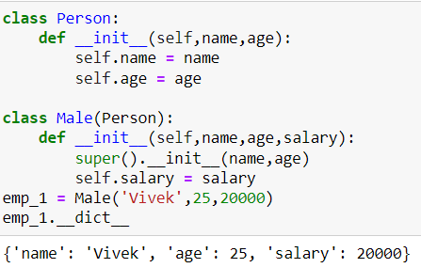

5. How is the local scope of a class different from that of a function?

Ans: The variables defined in the local scope of a function can be accessed only inside the function, and can not be accessed outside the function.

Similarly the variables defined in the local scope of a class can be either class variables or instance variables. Both of them can be accessed inside the class, and they can also be accessed outside the class by either class's name or instance's name.